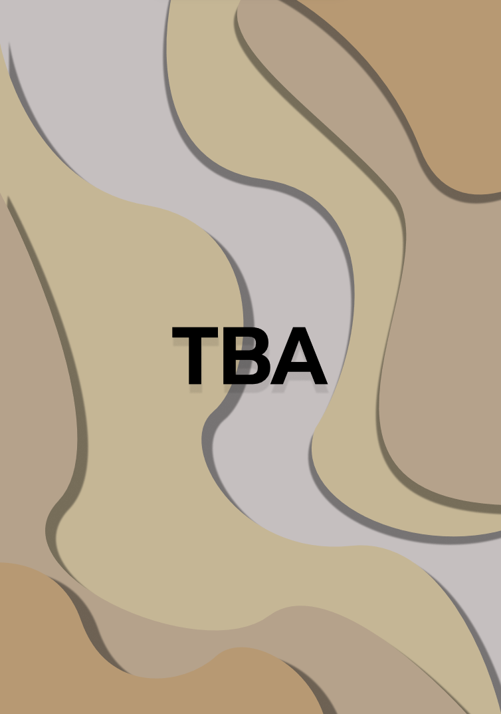

**Contents**

1.Project description 3

2. Team information 3

3. Project information 3

4. Technologies used 4

5. Ways of Realization 5

6. Work Plan 6

# **Project description**

* It’s an ecosystem simulator where you watch the evolution of rabbits and foxes
* The project was built by using “raylib”, “ImGui” and C++

# **Team information**

|  |  |  |
| --- | --- | --- |
| № | Name | Role |
| 1 | Maria Koleva | Scrum trainer |
| 2 | Ivan Stoychev | Back-end Developer |
| 3 | Ivelin Bozhilov | Designer |
| 4 | Stelian Mikov | Back-end Developer |

# **Project information**

|  |  |
| --- | --- |
| № | Information |
| 1 | **Description**  It’s an ecosystem simulator where you watch the evolution of rabbits and foxes |
| 2 | **Installation**  To install the project, you can open our GitHub repository and follow the instruction in the README.md file. |
| 3 | **Communication**  For communicate we used Teams. Which made it easy to share file and text messages. |

# 

# **Technologies used**

|  |  |  |
| --- | --- | --- |
| 1 | Technologies | Usage |
| 2 | Visual Studio 2022 | As out IDE |
| 3 | Visual Studio Code 2022 | As out IDE / Text editor |
| 4 | GitHub and Git | For collaboration |
| 5 | C++ | As programming language |
| 6 | Raylib | As a graphical library |
| 7 | ImGui | As a control renderer |
| 8 | Premake-core | As a build system |
| 9 | Python | For startup script |
| 10 | Word | For the documentation |
| 11 | Doxygen | For the code documentation |
| 12 | PowerPoint | For the presentation |
| 13 | Excel | For the QA documentation |
| 14 | Teams | For communication |
| 15 | Figma | For the UI / UX design |
| 16 | Blender | For the object creation |
| 17 | Netlify | To host the doxygen docs |

# 

# **Ways of Realization**

|  |  |  |
| --- | --- | --- |
| № | Issue | Solution |
| 1 | Task Distribution | When we distributed the tasks, we took in consideration the skills of each member and where he could be most productive.  For each task we made a GitHub issue which helped us to stay in track and made it easy for each member to see his tasks. |
| 2 | Task Completion | There were team meetings almost every day where we discussed problem and the overall state of the project.  Each member worked in a convenient for him time. When he was ready with his part of the project, he committed it to GitHub and closed the respective issue. This made it easy to track the progress of the project. |
| 3 | Deadlines | In our GitHub repository there were also milestones for each of the four weeks.  We split out issues based on how hard they are and how necessary they are for the project. |

# **Work Plan**

|  |  |
| --- | --- |
| № | Task Description |
| 1 | **Translate 2D into the 3D world**  The translation of 2D into the 3D world was made by our Back-end developers. The translation involves converting instructions or specifications related to two-dimensional concepts into their three-dimensional counterparts. |
| 2 | **Add map**  The maps were made by out Back-end developers. The maps enhance user experience and provide location-based functionalities. |
| 3 | **Add layer**  The creation layers were made by out Back-end developers. The layers allow users to create, edit, delete, and make their own layers according to their preferences. |
| 4 | **Make see-through layers**  The see-through layers were made by out Back-end developers. The transparent layers enhance users experience and provide transparency for visual elements. |
| 5 | **Add animal slider**  The animal slider was made by out Back-end developers. The animal sliders allow users to select number of animals and spawn them into the simulation and watch their evolution. |
| 6 | **Create 3D models**  The 3D models were made by our Scrum Trainer and our Designer. The 3D models enhance visual representation of foxes, rabbits and blocks. |
| 7 | **Add entity movement**  The entity movement was made by out Back-end developers. The entity movements create a mor interactive and engaging user experience. |
| 8 | **Add reproductive system**  The reproductive system was made by out Back-end developers. The reproductive system provides animals the need of eating, drinking and their reproductive urge. |
| 9 | **Add new font**  The creation of maps was made by out Designer and Back-end developers. The new font enhances visual aesthetics. |
| 10 | **Create QA documentation** The documentation was created by our QA engineer |
| 11 | **Create documentation** The documentation was created by our Scrum Trainer to show of process of work in our team |
| 12 | **Create presentation** The presentation was created by our Scrum Trainer |